**Problem Statement:**

Design a menu-driven program that allows users to perform various operations on a **singly linked list**. The program should provide options to insert elements into the linked list, delete elements from the linked list, search for an element in the linked list, and display the elements of the linked list. The user should be able to choose any of these operations from a menu and provide the required inputs.

The program should implement the following functionalities:

1. Linked List Initialization:

2. Insertion:

3. Deletion:

4. Search:

5. Display:

6. Exit:

The program should display a menu with the above options and allow the user to select an operation by entering the corresponding menu number. After executing the selected operation, the program should return to the menu and continue until the user chooses the exit option.

**Source Code:**

#include <stdio.h>

#include <stdlib.h>

// Linked List Node

struct node {

int info;

struct node* link;

};

struct node* start = NULL;

// Function to create list with n nodes initially

void createList()

{

if (start == NULL) {

int n;

printf("\nEnter the number of nodes: ");

scanf("%d", &n);

if (n != 0) {

int data;

struct node* newnode;

struct node* temp;

newnode = malloc(sizeof(struct node));

start = newnode;

temp = start;

printf("\nEnter number to"

" be inserted : ");

scanf("%d", &data);

start->info = data;

for (int i = 2; i <= n; i++) {

newnode = malloc(sizeof(struct node));

temp->link = newnode;

printf("\nEnter number to"

" be inserted : ");

scanf("%d", &data);

newnode->info = data;

temp = temp->link;

}

}

printf("\nThe list is created\n");

}

else

printf("\nThe list is already created\n");

}

// Function to traverse the linked list

void traverse()

{

struct node* temp;

// List is empty

if (start == NULL)

printf("\nList is empty\n");

// Else print the LL

else {

temp = start;

while (temp != NULL) {

printf("Data = %d\n", temp->info);

temp = temp->link;

}

}

}

// Function to insert at the front

// of the linked list

void insertAtFront()

{

int data;

struct node* temp;

temp = malloc(sizeof(struct node));

printf("\nEnter number to"

" be inserted : ");

scanf("%d", &data);

temp->info = data;

// Pointer of temp will be

// assigned to start

temp->link = start;

start = temp;

}

// Function to insert at the end of

// the linked list

void insertAtEnd()

{

int data;

struct node *temp, *head;

temp = malloc(sizeof(struct node));

// Enter the number

printf("\nEnter number to"

" be inserted : ");

scanf("%d", &data);

// Changes links

temp->link = 0;

temp->info = data;

head = start;

while (head->link != NULL) {

head = head->link;

}

head->link = temp;

}

// Function to insert at any specified

// position in the linked list

void insertAtPosition()

{

struct node *temp, *newnode;

int pos, data, i = 1;

newnode = malloc(sizeof(struct node));

// Enter the position and data

printf("\nEnter position and data :");

scanf("%d %d", &pos, &data);

// Change Links

temp = start;

newnode->info = data;

newnode->link = 0;

while (i < pos - 1) {

temp = temp->link;

i++;

}

newnode->link = temp->link;

temp->link = newnode;

}

// Function to delete from the front

// of the linked list

void deleteFirst()

{

struct node* temp;

if (start == NULL)

printf("\nList is empty\n");

else {

temp = start;

start = start->link;

free(temp);

}

}

// Function to delete from the end

// of the linked list

void deleteEnd()

{

struct node *temp, *prevnode;

if (start == NULL)

printf("\nList is Empty\n");

else {

temp = start;

while (temp->link != 0) {

prevnode = temp;

temp = temp->link;

}

free(temp);

prevnode->link = 0;

}

}

// Function to delete from any specified

// position from the linked list

void deletePosition()

{

struct node *temp, *position;

int i = 1, pos;

// If LL is empty

if (start == NULL)

printf("\nList is empty\n");

// Otherwise

else {

printf("\nEnter index : ");

// Position to be deleted

scanf("%d", &pos);

position = malloc(sizeof(struct node));

temp = start;

// Traverse till position

while (i < pos - 1) {

temp = temp->link;

i++;

}

// Change Links

position = temp->link;

temp->link = position->link;

// Free memory

free(position);

}

}

// Function to find the maximum element

// in the linked list

void maximum()

{

int a[10];

int i;

struct node* temp;

// If LL is empty

if (start == NULL)

printf("\nList is empty\n");

// Otherwise

else {

temp = start;

int max = temp->info;

// Traverse LL and update the

// maximum element

while (temp != NULL) {

// Update the maximum

// element

if (max < temp->info)

max = temp->info;

temp = temp->link;

}

printf("\nMaximum number "

"is : %d ",

max);

}

}

// Function to find the mean of the

// elements in the linked list

void mean()

{

int a[10];

int i;

struct node* temp;

// If LL is empty

if (start == NULL)

printf("\nList is empty\n");

// Otherwise

else {

temp = start;

// Stores the sum and count of

// element in the LL

int sum = 0, count = 0;

float m;

// Traverse the LL

while (temp != NULL) {

// Update the sum

sum = sum + temp->info;

temp = temp->link;

count++;

}

// Find the mean

m = sum / count;

// Print the mean value

printf("\nMean is %f ", m);

}

}

// Function to sort the linked list

// in ascending order

void sort()

{

struct node* current = start;

struct node* index = NULL;

int temp;

// If LL is empty

if (start == NULL) {

return;

}

// Else

else {

// Traverse the LL

while (current != NULL) {

index = current->link;

// Traverse the LL nestedly

// and find the minimum

// element

while (index != NULL) {

// Swap with it the value

// at current

if (current->info > index->info) {

temp = current->info;

current->info = index->info;

index->info = temp;

}

index = index->link;

}

// Update the current

current = current->link;

}

}

}

// Function to reverse the linked list

void reverseLL()

{

struct node *t1, *t2, *temp;

t1 = t2 = NULL;

// If LL is empty

if (start == NULL)

printf("List is empty\n");

// Else

else {

// Traverse the LL

while (start != NULL) {

// reversing of points

t2 = start->link;

start->link = t1;

t1 = start;

start = t2;

}

start = t1;

// New head Node

temp = start;

printf("Reversed linked "

"list is : ");

// Print the LL

while (temp != NULL) {

printf("%d ", temp->info);

temp = temp->link;

}

}

}

// Function to search an element in linked list

void search()

{

int found = -1;

// creating node to traverse

struct node* tr = start;

// first checking if the list is empty or not

if (start == NULL) {

printf("Linked list is empty\n");

}

else {

printf("\nEnter the element you want to search: ");

int key;

scanf("%d", &key);

// checking by traversing

while (tr != NULL) {

// checking for key

if (tr->info == key) {

found = 1;

break;

}

// moving forward if not at this position

else {

tr = tr->link;

}

}

// printing found or not

if (found == 1) {

printf(

"Yes, %d is present in the linked list.\n",

key);

}

else {

printf("No, %d is not present in the linked "

"list.\n",

key);

}

}

}

// Driver Code

int main()

{

printf("Yogesh Pal Parmar MCA 2B 70\n");

int choice;

while (1) {

printf("\n\t1 To see list\n");

printf("\t2 For insertion at"

" starting\n");

printf("\t3 For insertion at"

" end\n");

printf("\t4 For insertion at "

"any position\n");

printf("\t5 For deletion of "

"first element\n");

printf("\t6 For deletion of "

"last element\n");

printf("\t7 For deletion of "

"element at any position\n");

printf("\t8 To find maximum among"

" the elements\n");

printf("\t9 To find mean of "

"the elements\n");

printf("\t10 To sort element\n");

printf("\t11 To reverse the "

"linked list\n");

printf("\t12 Search an element in linked list\n");

printf("\t13 To exit\n");

printf("\nEnter Choice :\n");

scanf("%d", &choice);

switch (choice) {

case 1:

traverse();

break;

case 2:

insertAtFront();

break;

case 3:

insertAtEnd();

break;

case 4:

insertAtPosition();

break;

case 5:

deleteFirst();

break;

case 6:

deleteEnd();

break;

case 7:

deletePosition();

break;

case 8:

maximum();

break;

case 9:

mean();

break;

case 10:

sort();

break;

case 11:

reverseLL();

break;

case 12:

search();

break;

case 13:

exit(1);

break;

default:

printf("Incorrect Choice\n");

}

} return 0; }

**Output:**

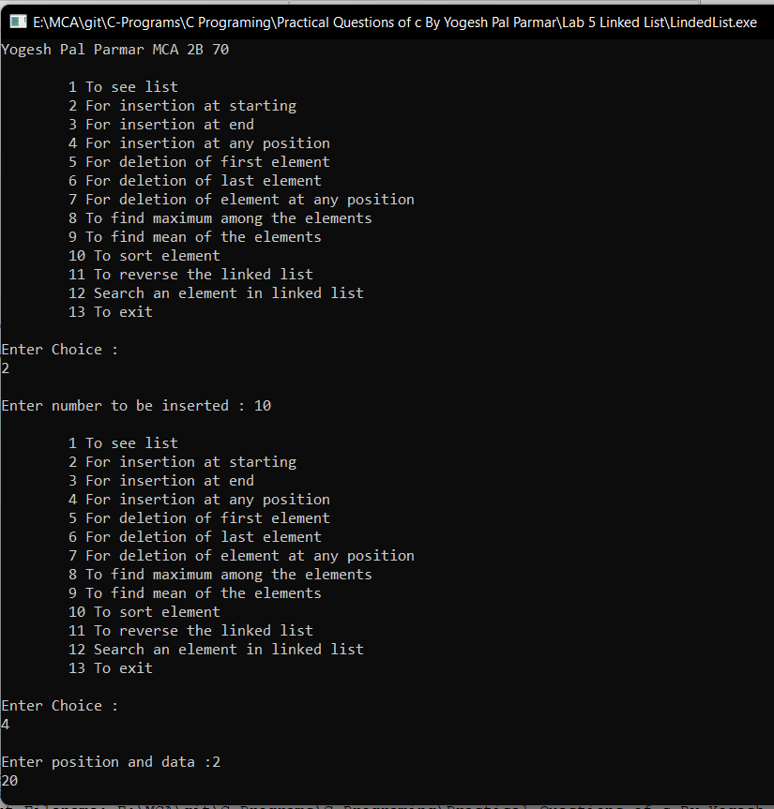

**Problem Statement:**

Design a menu-driven program that allows users to perform various operations on a **doubly linked list**. The program should provide options to insert elements into the doubly linked list, delete elements from the doubly linked list, search for an element in the doubly linked list, and display the elements of the doubly linked list in both forward and backward order. The user should be able to choose any of these operations from a menu and provide the required inputs.

The program should implement the following functionalities:

1. Doubly Linked List Initialization:

2. Insertion:

3. Deletion:

4. Search:

5. Display Forward:

6. Display Backward:

7. Exit:

The program should display a menu with the above options and allow the user to select an operation by entering the corresponding menu number. After executing the selected operation, the program should return to the menu and continue until the user chooses the exit option.

**Source Code:**

// C program for the all operations in

// the Doubly Linked List

#include <stdio.h>

#include <stdlib.h>

// Linked List Node

struct node {

int info;

struct node *prev, *next;

};

struct node* start = NULL;

// Function to traverse the linked list

void traverse()

{

// List is empty

if (start == NULL) {

printf("\nList is empty\n");

return;

}

// Else print the Data

struct node* temp;

temp = start;

while (temp != NULL) {

printf("Data = %d\n", temp->info);

temp = temp->next;

}

}

// Function to insert at the front

// of the linked list

void insertAtFront()

{

int data;

struct node* temp;

temp = (struct node*)malloc(sizeof(struct node));

printf("\nEnter number to be inserted: ");

scanf("%d", &data);

temp->info = data;

temp->prev = NULL;

// Pointer of temp will be

// assigned to start

temp->next = start;

start = temp;

}

// Function to insert at the end of

// the linked list

void insertAtEnd()

{

int data;

struct node *temp, *trav;

temp = (struct node*)malloc(sizeof(struct node));

temp->prev = NULL;

temp->next = NULL;

printf("\nEnter number to be inserted: ");

scanf("%d", &data);

temp->info = data;

temp->next = NULL;

trav = start;

// If start is NULL

if (start == NULL) {

start = temp;

}

// Changes Links

else {

while (trav->next != NULL)

trav = trav->next;

temp->prev = trav;

trav->next = temp;

}

}

// Function to insert at any specified

// position in the linked list

void insertAtPosition()

{

int data, pos, i = 1;

struct node *temp, *newnode;

newnode = malloc(sizeof(struct node));

newnode->next = NULL;

newnode->prev = NULL;

// Enter the position and data

printf("\nEnter position : ");

scanf("%d", &pos);

// If start==NULL,

if (start == NULL) {

start = newnode;

newnode->prev = NULL;

newnode->next = NULL;

}

// If position==1,

else if (pos == 1) {

// this is author method its correct but we can simply call insertAtfront() function for this special case

/* newnode->next = start;

newnode->next->prev = newnode;

newnode->prev = NULL;

start = newnode; */

insertAtFront();

}

// Change links

else {

printf("\nEnter number to be inserted: ");

scanf("%d", &data);

newnode->info = data;

temp = start;

while (i < pos - 1) {

temp = temp->next;

i++;

}

newnode->next = temp->next;

newnode->prev = temp;

temp->next = newnode;

temp->next->prev = newnode;

}

}

// Function to delete from the front

// of the linked list

void deleteFirst()

{

struct node* temp;

if (start == NULL)

printf("\nList is empty\n");

else {

temp = start;

start = start->next;

if (start != NULL)

start->prev = NULL;

free(temp);

}

}

// Function to delete from the end

// of the linked list

void deleteEnd()

{

struct node* temp;

if (start == NULL)

printf("\nList is empty\n");

temp = start;

while (temp->next != NULL)

temp = temp->next;

if (start->next == NULL)

start = NULL;

else {

temp->prev->next = NULL;

free(temp);

}

}

// Function to delete from any specified

// position from the linked list

void deletePosition()

{

int pos, i = 1;

struct node *temp, *position;

temp = start;

// If DLL is empty

if (start == NULL)

printf("\nList is empty\n");

// Otherwise

else {

// Position to be deleted

printf("\nEnter position : ");

scanf("%d", &pos);

// If the position is the first node

if (pos == 1) {

deleteFirst(); // im,proved by Jay Ghughriwala on GeeksforGeeks

if (start != NULL) {

start->prev = NULL;

}

free(position);

return;

}

// Traverse till position

while (i < pos - 1) {

temp = temp->next;

i++;

}

// Change Links

position = temp->next;

if (position->next != NULL)

position->next->prev = temp;

temp->next = position->next;

// Free memory

free(position);

}

}

// Driver Code

int main()

{

printf("Yogesh Pal Parmar MCA 2B 70\n");

int choice;

while (1) {

printf("\n\t1 To see list\n");

printf("\t2 For insertion at"

" starting\n");

printf("\t3 For insertion at"

" end\n");

printf("\t4 For insertion at "

"any position\n");

printf("\t5 For deletion of "

"first element\n");

printf("\t6 For deletion of "

"last element\n");

printf("\t7 For deletion of "

"element at any position\n");

printf("\t8 To exit\n");

printf("\nEnter Choice :\n");

scanf("%d", &choice);

switch (choice) {

case 1:

traverse();

break;

case 2:

insertAtFront();

break;

case 3:

insertAtEnd();

break;

case 4:

insertAtPosition();

break;

case 5:

deleteFirst();

break;

case 6:

deleteEnd();

break;

case 7:

deletePosition();

break;

case 8:

exit(1);

break;

default:

printf("Incorrect Choice. Try Again \n");

continue;

}

return 0; }

**Output:**

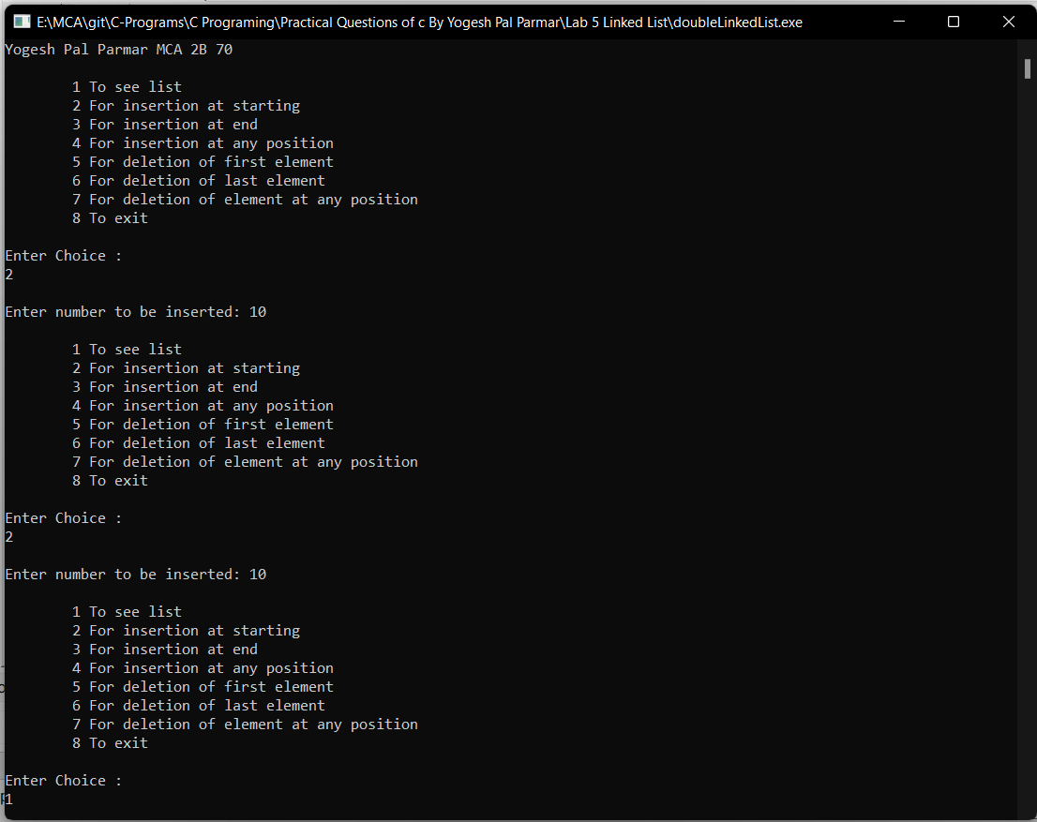

**Problem Statement:**

Design a menu-driven program that allows users to perform various operations on a **circular linked list**. The program should provide options to insert elements into the circular linked list, delete elements from the circular linked list, search for an element in the circular linked list, and display the elements of the circular linked list. The user should be able to choose any of these operations from a menu and provide the required inputs.

The program should implement the following functionalities:

1. Circular Linked List Initialization:

2. Insertion:

3. Deletion:

4. Search:

5. Display:

6. Exit:

The program should display a menu with the above options and allow the user to select an operation by entering the corresponding menu number. After executing the selected operation, the program should return to the menu and continue until the user chooses the exit option.

**Source Code:**

#include<stdio.h>

#include<stdlib.h>

struct node

{

int data;

struct node *next;

};

struct node *head;

void beginsert ();

void lastinsert ();

void randominsert();

void begin_delete();

void last_delete();

void random_delete();

void display();

void search();

void main ()

{

printf("Yogesh Pal Parmar MCA 2B 70\n");

int choice =0;

while(choice != 7)

{

printf("\n*********Main Menu*********\n");

printf("\nChoose one option from the following list ...\n");

printf("\n===============================================\n");

printf("\n1.Insert in begining\n2.Insert at last\n3.Delete from Beginning\n4.Delete from last\n5.Search for an element\n6.Show\n7.Exit\n");

printf("\nEnter your choice?\n");

scanf("\n%d",&choice);

switch(choice)

{

case 1:

beginsert();

break;

case 2:

lastinsert();

break;

case 3:

begin_delete();

break;

case 4:

last_delete();

break;

case 5:

search();

break;

case 6:

display();

break;

case 7:

exit(0);

break;

default:

printf("Please enter valid choice..");

}

}

}

void beginsert()

{

struct node *ptr,*temp;

int item;

ptr = (struct node *)malloc(sizeof(struct node));

if(ptr == NULL)

{

printf("\nOVERFLOW");

}

else

{

printf("\nEnter the node data?");

scanf("%d",&item);

ptr -> data = item;

if(head == NULL)

{

head = ptr;

ptr -> next = head;

}

else

{

temp = head;

while(temp->next != head)

temp = temp->next;

ptr->next = head;

temp -> next = ptr;

head = ptr;

}

printf("\nnode inserted\n");

}

}

void lastinsert()

{

struct node *ptr,*temp;

int item;

ptr = (struct node *)malloc(sizeof(struct node));

if(ptr == NULL)

{

printf("\nOVERFLOW\n");

}

else

{

printf("\nEnter Data?");

scanf("%d",&item);

ptr->data = item;

if(head == NULL)

{

head = ptr;

ptr -> next = head;

}

else

{

temp = head;

while(temp -> next != head)

{

temp = temp -> next;

}

temp -> next = ptr;

ptr -> next = head;

}

printf("\nnode inserted\n");

}

}

void begin_delete()

{

struct node *ptr;

if(head == NULL)

{

printf("\nUNDERFLOW");

}

else if(head->next == head)

{

head = NULL;

free(head);

printf("\nnode deleted\n");

}

else

{ ptr = head;

while(ptr -> next != head)

ptr = ptr -> next;

ptr->next = head->next;

free(head);

head = ptr->next;

printf("\nnode deleted\n");

}

}

void last_delete()

{

struct node *ptr, *preptr;

if(head==NULL)

{

printf("\nUNDERFLOW");

}

else if (head ->next == head)

{

head = NULL;

free(head);

printf("\nnode deleted\n");

}

else

{

ptr = head;

while(ptr ->next != head)

{

preptr=ptr;

ptr = ptr->next;

}

preptr->next = ptr -> next;

free(ptr);

printf("\nnode deleted\n");

}

}

void search()

{

struct node *ptr;

int item,i=0,flag=1;

ptr = head;

if(ptr == NULL)

{

printf("\nEmpty List\n");

}

else

{

printf("\nEnter item which you want to search?\n");

scanf("%d",&item);

if(head ->data == item)

{

printf("item found at location %d",i+1);

flag=0;

}

else

{

while (ptr->next != head)

{

if(ptr->data == item)

{

printf("item found at location %d ",i+1);

flag=0;

break;

}

else

{

flag=1;

}

i++;

ptr = ptr -> next;

}

}

if(flag != 0)

{

printf("Item not found\n");

}

}

}

void display()

{

struct node *ptr;

ptr=head;

if(head == NULL)

{

printf("\nnothing to print");

}

else

{

printf("\n printing values ... \n");

while(ptr -> next != head)

{

printf("%d\n", ptr -> data);

ptr = ptr -> next;

}

printf("%d\n", ptr -> data);

}

}

**Output:**

